**ABHIJIT DASH**

**RA1811031010112**

**SHIFT REDUCE PARSER**

**AIM:-**

To compute shift reduce parser for the given grammar.

**CODE:-**

#include<stdio.h>

#include<stdlib.h>

#include<conio.h>

#include<string.h>

char ip_sym[15],stack[15];

int ip_ptr=0,st_ptr=0,len,i;

char temp[2],temp2[2];

char act[15];

void check();

void main()

{

clrscr();

printf("\n\t\t SHIFT REDUCE PARSER\n");

printf("\n GRAMMER\n");

printf("\n E->E+E\n E->E/E");

printf("\n E->E*E\n E->a/b");

printf("\n enter the input symbol:\t");

gets(ip_sym);

printf("\n\t stack implementation table");

printf("\n stack \t\t input symbol\t\t action");

printf("\n________\t\t____________\t\t____________\n");

printf("\n $\t\t%s$\t\t\t--",ip_sym);

strcpy(act,"shift");

temp[0]=ip_sym[ip_ptr];

temp[1]='\0';

strcat(act,temp);

len=strlen(ip_sym);

for(i=0;i<=len-1;i++)

{

stack[st_ptr]=ip_sym[ip_ptr];

stack[st_ptr+1]='\0';

ip_sym[ip_ptr]=' ';

ip_ptr++;

printf("\n $%s\t\t%s$\t\t\t%s",stack,ip_sym,act);

strcpy(act,"shift");

temp[0]=ip_sym[ip_ptr];

temp[1]='\0';

strcat(act,temp);

check();

st_ptr++;

}

st_ptr++;

check();

}

void check()

{

int flag=0;

temp2[0]=stack[st_ptr];

temp2[1]='\0';

if((!strcmpi(temp2,"a"))||(!strcmpi(temp2,"b")))

{

stack[st_ptr]='E';

if(!strcmpi(temp2,"a"))

printf("\n $%s\t\t%s$\t\t\tE->a",stack,ip_sym);

else

printf("\n $%s\t\t%s$\t\t\tE->b",stack,ip_sym);

flag=1;

}

if((!strcmpi(temp2,"+"))||(strcmpi(temp2,"*"))||(!strcmpi(temp2,"/")))

{

flag=1;

}

if((!strcmpi(stack,"E+E"))||(!strcmpi(stack,"E\E"))||(!strcmpi(stack,"E*E")))

{

strcpy(stack,"E");

st_ptr=0;

if(!strcmpi(stack,"E+E"))

printf("\n $%s\t\t%s$\t\t\tE->E+E",stack,ip_sym);

else

if(!strcmpi(stack,"E\E"))

printf("\n $%s\t\t%s$\t\t\tE->E\E",stack,ip_sym);

else

if(!strcmpi(stack,"E*E"))

printf("\n $%s\t\t%s$\t\t\tE->E*E",stack,ip_sym);

else

printf("\n $%s\t\t%s$\t\t\tE->E+E",stack,ip_sym);

flag=1;

}

if(!strcmpi(stack,"E")&&ip_ptr==len)

{

printf("\n $%s\t\t%s$\t\t\tACCEPT",stack,ip_sym);

getch();

exit(0);

}

if(flag==0)

{

printf("\n%s\t\t\t%s\t\t reject",stack,ip_sym);

exit(0);

}

return;}

**OUTPUT SCREENSHOT:-**

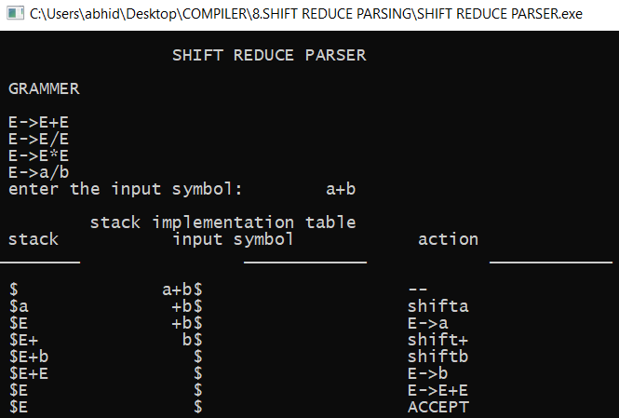

**RESULT:-**

The output was generated successfully for the given production of a grammar.